ALL:
angrir -
shusug -
taron -
sharast +
stidest +

DUNNO:
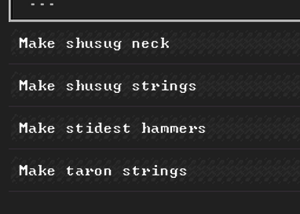

METAL:

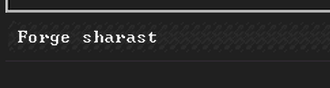
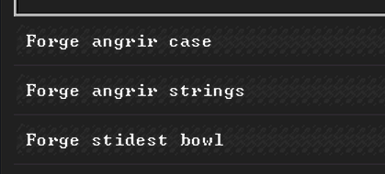

CLAY:
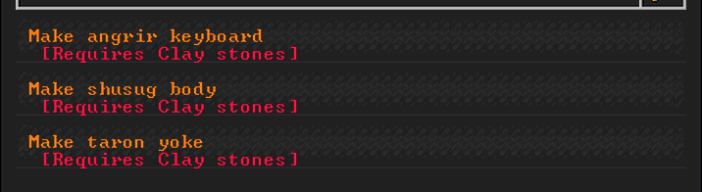

GLASS:
